SOFTWARE REQUIREMENT SPECIFICATION (SRS)

ONLINE CAR RENTAL MANAGEMENT SYSTEM



2016

[GOLDEN DEVELOPMENT ENTERPRISE]

To be submitted to the Software Planning & Requirement Workshop

Bachelor of Computer Science (Software Engineering)

# DOCUMENT APPROVAL

|  |  |  |
| --- | --- | --- |
|  | **Name** | **Date** |
| **Authenticated by:**  \_\_\_\_\_\_\_\_\_\_\_\_\_\_\_\_\_\_\_\_\_\_\_  Project Manager | Sivapriyan A/L S Kummar |  |
| **Approved by:**  \_\_\_\_\_\_\_\_\_\_\_\_\_\_\_\_\_\_\_\_\_\_\_    Client | Badrul Hanafi bin Ramli |  |

Software : Microsoft Word 2013, Rational Software Architecture, Microsoft

Visio 2013,WIX

Archiving Place :

Copies Available : Hardcopy 2 sets

TABLE OF CONTENTS

[DOCUMENT APPROVAL ii](#_Toc208811441)

[TABLE OF CONTENTS iii](#_Toc208811442)

[LIST OF FIGURES iv](#_Toc208811443)

[LIST OF TABLES iv](#_Toc208811444)

[LIST OF APPENDIXES vi](#_Toc208811445)

[1. INTRODUCTION 1](#_Toc208811446)

[1.1 PURPOSE 1](#_Toc208811447)

[1.2 SYSTEM IDENTIFICATION 1](#_Toc208811448)

[1.3 SYSTEM OVERVIEW](#_Toc208811449) 2

[1.4 REFERENCES](#_Toc208811449) 4

[1.5 DOCUMENT OVERVIEW](#_Toc208811450) 5

[2. PRODUCT DESCRIPTION](#_Toc208811451) 6

[2.1 PRODUCT PERSPECTIVE](#_Toc208811452) 6

[2.2 SYSTEM INTERFACES](#_Toc208811453) 7

[2.3 PRODUCT FUNCTIONS 9](#_Toc208811456)

[2.4 USER CHARACTERISTICS 10](#_Toc208811457)

[2.5 CONSTRAINTS 10](#_Toc208811458)

[2.6 ASSUMPTIONS AND DEPENDENCIES 11](#_Toc208811459)

[3. SPECIFIC REQUIREMENTS 12](#_Toc208811460)

[3.1 SOFTWARE PRODUCT FEATURES 13](#_Toc208811463)

[3.1.1 USE CASE NAME 13](#_Toc208811464)

[3.2 USER INTERFACES REQUIREMENTS 26](#_Toc208811461)

[3.2.1 GRAPHICAL USER INTERFACES 26](#_Toc208811462)

[3.2.3 HARDWARE INTERFACES 28](#_Toc208811462)

[3.2.4 SOFTWARE INTERFACES 28](#_Toc208811462)

[3.3 REQUIREMENTS TRACEBILITY 29](#_Toc208811465)

[4. ACRONYMS AND ABBREVIATION 32](#_Toc208811466)

# LIST OF FIGURES

[Figure 2.1 Context Diagram of the OCRMS](#_Toc208811441) 6

[Figure 2.2 Use Case for OCRMS](#_Toc208811442) 9

[Figure 3.1 Use Case for Register Module](#_Toc208811443) 13

Figure 3.2 Use Case for Login Module 15

Figure 3.3 [Use Case for Booking Module](#_Toc208811441) 17

[Figure 3.4 Use Case for Management Module](#_Toc208811442) 20

[Figure 3.5 Use Case for Customer Information Module](#_Toc208811443) 22

[Figure 3.6 Use Case for Generating Module](#_Toc208811441) 24

[Figure 3.7 Dialogue Diagram for OCRMS](#_Toc208811442) 26

[Figure 3.8 Traceability Matrix for B](#_Toc208811443) 31

# LIST OF TABLES

[Table 2.1 List of Interfaces](#_Toc208811441) 7

[Table 2.2 List of Actor](#_Toc208811442) 8

[Table 2.3 User Characteristic](#_Toc208811443) 10

[Table](#_Toc208811446) 3.1 List Of System Requirements 12

[Table 3.2 UCD for Register Module](#_Toc208811442) 14

[Table 3.3 UCD for Login Module](#_Toc208811443) 16

[Table](#_Toc208811446) 3.4 UCD for Booking Module 18

[Table 3.5 UCD for Management Module](#_Toc208811441) 21

[Table 3.6 UCD for Customer Information Module](#_Toc208811442) 23

[Table 3.7 UCD for Generating Module](#_Toc208811443) 25

[Table](#_Toc208811446) 3.8 Description Of User Interface Components 27

[Table 3.9 Traceability Matrix for A](#_Toc208811441) 29

[Table 3.10 Traceability Matrix for B](#_Toc208811442) 30

[Table 4.1 Terms and Definitions](#_Toc208811441) 32

LIST OF APPENDIXES

[Appendix A1 Sequence Diagram for Register Module](#_Toc208811442) 33

[Appendix A2 Sequence Diagram for Login Module](#_Toc208811442) 33

[Appendix A3 Sequence Diagram for Login Module](#_Toc208811442) 34

[Appendix A4 Sequence Diagram for Booking Module](#_Toc208811442) 34

[Appendix A5 Sequence Diagram for Booking Module](#_Toc208811442) 35

[Appendix A6 Sequence Diagram for Management Module](#_Toc208811442) 35

[Appendix A7 Sequence Diagram for Customer Info Module](#_Toc208811442) 36

[Appendix A8 Sequence Diagram for Generating Module](#_Toc208811442) 36

[Appendix B1 Home Interface](#_Toc208811442) 37

[Appendix B2 Registeration Interface](#_Toc208811442) 37

[Appendix B3 Home Interface after Login](#_Toc208811442) 38

[Appendix B4 Car Rental Interface](#_Toc208811442) 38

[Appendix B5 Booking Interface](#_Toc208811442) 39

[Appendix B6 About Us Interface](#_Toc208811442) 39

[Appendix B7 Contact Interface](#_Toc208811442) 40

[Appendix B8 Car Details Interface](#_Toc208811442) 40

[Appendix B9 Car Availability Interface](#_Toc208811442) 41

[Appendix B10 Customer Details Interface](#_Toc208811442) 41

[Appendix B11 Bill Interface](#_Toc208811442) 42

1. INTRODUCTION

## 

## 1.1 PURPOSE

The purpose of this Software Requirements Specification (SRS) document is to present the details description of the Online Car Rental Management System. These document explained the purpose and features of the system, the interfaces that being used, what the system can do, the constraint under which it must operate and how the system will react to external stimuli. This document is intended for both the stakeholders and the developers of the system.

## SYSTEM IDENTIFICATION

System name : Online Car Rental Management System.

System abbreviation : OCRMS

System identification : OCRMS-V.01-2016

## SYSTEM OVERVIEW

The objective of this project is to develop a web based computer system to support existing manual car rental management process.OCRMS will convert manual car rental management into a computerized system which is integrated with a database system.By this integration,the system is capable to insert,save, update, delete, retrieve records and data. This system can keep huge data organized, secured and may reduce the uses of lots of paper. This system is a web-based application which means that Graphic User Interfaces (GUI) are implemented using any web browser. By default it is an internet-based application whereas user need an internet connection to access this system. The users of this system are customer,employee and manager who have different level of authority and function access to the system .Plus, the outsider is able to access OCRMS home page as it is public.

The major activities of the system are supporting the management information of the car rental process which include the manipulating the specific data, which are booking,customers and cars details. By using this system, the customer can book car for rental online.This include modifying the booking details which include update and cancelling the booking.The employee can update car availability and info,view customer info and generate bill using this system.While the manager can use this system to view monthly rental reports.These system features makes the car rentaling process more efficient and less complicated while contributing to better management process.

PROBLEM STATEMENT

Nowadays, people are keep using the internet and computer based application everytime and everywhere they go.Plus,manual car rental process takes more time,tiring and tedious process. So,by developing an web based application makes the rental process more easier and convenient and it is necessary to keep the system up to date because we use a web based system which uses server to store data in the database and control the access to the system.

1. Reduce the use of paper which the data stored in the database is using the concept of cloud computing. When the use of paper reduces, the risk of the data loss is decreasing. The old manual systems use papers to store data and details of booking process and customer. Plus, the old process requires more space of working area and use additional equipments.

2. Save time for the employee to manage car information and customers in making the car reservations. All the information about car for rent is stored in the database. The payment also can be calculated automatically based on the rental period.

OBJECTIVES

1. To develop interactive web based system for the manual car rental process.
2. To allow employee to add, edit and delete car information which contains type of cars, rental price and availability of the car that want to rent.
3. To allow customers to book car according to type of car, price, date and time of car that they want to rent.
4. To design and build a particular model for user benefits.

## REFERENCES

1. Online Car Rental System

<http://www.academia.edu/16768137/Online_Car_Rental_System>

1. Space and Naval Warfare System, “Software Development Plan (SDP) for the Nato Interoperable Submarine Broadcast System (NISBS)”, 1.3v, 3 October 1999.

[http://www.letu.edu/people/jaytevis/Software-Engineering/Examples/SDP-For- NISBS.pdf](http://www.letu.edu/people/jaytevis/Software-Engineering/Examples/SDP-For-%20%20NISBS.pdf)

1. Tutorial Rational Software Architect

[https://www.ibm.com/developerworks/community/wikis/home?lang=en#!/wiki/W0c4 a14ff363e\_436c\_9962\_2254bb5cbc60/page/Tutorials+&+samples](https://www.ibm.com/developerworks/community/wikis/home?lang=en#!/wiki/W0c4          a14ff363e_436c_9962_2254bb5cbc60/page/Tutorials+&+samples)

1. UML Sequence Diagram, 06 April 2008

<http://www.tracemodeler.com/articles/a_quick_introduction_to_uml_sequence_diagrams/>

1. Car Rental System

http://www.planyo.com/car-rental-reservation-system.php

## 

## 1.5 DOCUMENT OVERVIEW

This Software Requirement Specification(SRS) document have four different part which is introduction, product description, specific requirements and acronyms and abbreviation.

The purpose of this document is to outline the entire requirement that has been gathered for the Online Car Rental Management System. In the first chapter, the identification of this system have been stated. Then the overview for the overall system are stated where all the functions provided by the system are explained with details. The reference that we refer also stated as prove.

The second chapter is the product description section, which gives an overview of the functionality of the product. It describes the informal requirements and is used to establish a context for a technical requirements specification in the third chapter.This chapter is more to explaining the system.It describes the user that will use the system, system function, the system constraints and the assumptions and dependencies. This to make sure that the client can understand the system flow and the weakness of system.OCRMS is accessible with any compatible browser such as Internet Explorer, Mozilla Firefox and Google Chrome.

Third chapter is specific requirement, it describes the software requirements to a level of more details that enables designers to design a system that satisfy those requirements and well-functioning as well. Besides that, it also explains every input and output of the system with all functions performed by the system in response.By this, client can get to know more about the product features, the interface requirements and the requirement traceability.

The fourth chapter, acronyms and abbreviations section, of this document is basically a table that has been constructed with all of the unfamiliar abbreviations such as OCRMS which stands for Online Car Rental Management System so if users come across an abbreviation that they are not familiar with they can simply turn to the table and look up the word they are looking for.

# 2. PRODUCT DESCRIPTION

**2.1** **Product Perspective**

The Online Car Rental Management System (OCRMS) is a client-server system. There are two ways of interaction between the customers,employee and manager. Employee and customer need to login to use the system while manager has direct access to the system. Customer can make booking and modifying the booking details while employee can manage customers ,cars and booking details.Manager can view monthly rental reports.



Figure 2.1

Figure 2.1 shows the context diagram of the Online Car Rental Management System flow interaction between the customer,employee,manager and the system.

### 2.2 System Interfaces

The system interface is a key and determines the application usability. Therefore, system interface must be user friendly and meet the user requirements. The homepage appear first.Then customer and employee need to login to access the system functions.

|  |  |
| --- | --- |
| **System Interface** | **Description** |
| Registration | Registration interface for customer. |
| Login | Login interface for customer and employee to login and access the system function. |
| Cars | Option for customer to search car and view car. |
| Home | Home interface that is visible to all user before login. |
| Availability | Interface for employee to update car availability. |
| Customer list | Interface for employee to view customer details. |
| Bill | Interface for employee to generate bill. |

Table 2.1 List Of Interfaces

|  |  |
| --- | --- |
| **Actor** | **Description** |
| Customer | The customer will be able to to register and make reservations of the car they preferred. They can search for a car and details of the car. |
| Employee | The employee could access the login detail from user who already register and use the system. Employee also can manage car information which include car availability and view customer details.Next, they also can generate bill based on rental period. |
| Manager | Manager is the person who can view monthly rental report. |

Table 2.2 List Of Actor

**2.3 Product Function**



Figure 2.2 Uce Case For OCMRS

## 2.4 User Characteristics

There are some minimum characteristics that the employee and manager must have in order to access this system.

|  |  |  |
| --- | --- | --- |
| User | Educational Level | Technical Expertise |
| Employee | Passed SPM examination | 1) Have computer skills to communicate with system user interface  2) Understand English language |
| Manager | Verified graduated business management | 1) Have computer skills to communicate with system user interface.  2) Understand English language |
| Customer | Literate | 1) Able to access the system  2) Understand English language  3)Owns active driving license |

## Table 2.3 User Characteristic

## 2.5 Constraints

Hardware and Software Constrain

* Internet is needed to access the system
* Hardware broke down and system could not be used at time
* System need time from 5 to 10 seconds to recover from crash
* Developer have limited knowledge about PHP programming language
* Software problems occur, system needs to be corrected by developer that will require some time to fix.
* Some operating system may not compatible with our system
* Some computer language may not compatible with our system and hardware
* Interface for other application may not compatible with what we already set in the system
* Data in the database may be redundant and sometimes system could not store the data that at a time
* Safety : System may be lack of security and it might can be hack by third party

## 2.6 Assumptions and Dependencies

There are several assumptions and dependencies that provided in our system :

**Assumption**

1. The data that customer and employee insert in the system are secure. The data are private and protected from other except for the system user.
2. Each user has their account and no one can access the other’s accounts.
3. The system will connected to the interior database.
4. The system allow user to make registration.
5. This system designed can be run in any of internet browser such as Mozilla Firefox and Internet Explorer.
6. The system is user friendly and user will easily understand how to use the system.

**Dependencies**

1. The system are secure with network that implement with firewalls, running antispyware and virus detection programs on servers and network-addressed storage systems.
2. Provided information to each customer to turn on their compatible view with using developer tools.
3. The login part are useful to make sure that each user only can access their account.
4. Network should always be available.
5. The system can be access when the network are available.

# 3. SPECIFIC REQUIREMENTS

|  |  |
| --- | --- |
| SFR-OCRMS-RM-01 | Customer should be allowed to register themselves to use the system by choosing a unique id and password during the registration process. |
| SFR-OCRMS-LM-01 | Customer should be able to login into the system using the unique id and password at any time. |
| SFR-OCRMS-LM-02 | Employee should be able to login into the system using the unique id and password at any time. |
| SFR-OCRMS-BM-01 | Customer should be able to view the cars info. |
| SFR-OCRMS-BM-02 | Employee should be able to update car availability periodically. |
| SFR-OCRMS-BM-03 | Employee should be able to update car details by using add,delete and update function. |
| SFR-OCRMS-BM-04 | Customer should be able to book a car that is available at any time. |
| SFR-OCRMS-BM-05 | Customer should be able modify booking by using delete and update function without any constraints. |
| SFR-OCRMS-BM-06 | Employee should be able to manage booking any time without any constraints. |
| SFR-OCRMS-BM-07 | Manager should be able to view monthly reports at any time without any constraints. |
| SFR-OCRMS-FM-01 | Employee should be able to get the booking details from the system to generate receipt. |
| SFR-OCRMS-IM-01 | Employee should be able to modify cars info any time. |
| SFR-OCRMS-CM-01 | Employee should be able to view customers info any time without any constraints and difficulty. |

Table 3.1 List Of System Requirements

## SOFTWARE PRODUCT FEATURES

* + 1. Use Case Register



### Figure 3.1 Use Case for Register Module

This use case diagram show the actor that use the sub-system in the OCRMS. The actor are customer who will use the registration module to register to use the car rental system.

Table 3.2 UCD for Register Module

|  |  |
| --- | --- |
| **Use Case ID** | OCRMS-UC-01 |
| **Use Case Name** | Register |
| **Brief Description** | This use case is use to register by a new customer who want to use the system. |
| **Actor** | Customers |
| **Pre-Conditions** | Access the system and “Registration” hyperlink is clicked. |
| **Basic Flow** | 1. After customer access homepage of the system, customer is allowed to click the “registration” hyperlink. 2. When customer clicks the “registration” hyperlink, the system display a form to be filled up. 3. Customer fill up the required details. 4. Success registration results in a popup message “Success registration” and customer will be directed to home page. |
| **Alternative Flow** | Customer cannot register.   1. Check internet connection 2. Reload the page 3. Show guide for registeration |
| **Exception Flow** | Error during filling up the form   1. System alert the customer about the error. 2. System automatically highlight the part where customer made mistake. 3. System show guide for registeration. |
| **Post-Conditions** | Customer is successfully registered and can use the system. |
| **Rules** | Customer must choose a unique username and password. |
| **Constraints** | 1. Need to check the internet connection 2. Choose unique username and password |
| **Sequence Diagram** | Refer Appendix A1 Sequence Diagram |

3.1.2 Use Case login



Figure 3.2 Use Case for Login Module

This use case diagram show the actor that use the sub-system in the OCRMS. The customer and employee use the login module to enter the system.

First, they need to enter a valid username and password to access the system and to use the system function.

Table 3.3 UCD for Login Module

|  |  |
| --- | --- |
| **Use Case ID** | OCRMS-UC-02 |
| **Use Case Name** | Login |
| **Brief Description** | This use case is use by customer and employee to login. |
| **Actor** | Employee,Customer |
| **Pre-Conditions** | Employee and Customer must have unique ID and exist in database. |
| **Basic Flow** | Employee   1. After employee click the “Login” button, the system launches the login screen. 2. Employee enters a combination of username and password. 3. System validate the combination and logins the employee successfully.   Customer   1. After customer click the “Login” button, the system launches the login screen. 2. Customer enters a combination of username and password. 3. System validate the combination and logins the customer successfully. |
| **Alternative Flow** | Incorrect username/password combination   1. System validation of the username/password combination fails due to incorrect entry. 2. System pop-up “login error” message and asks the employee to re-enter the username/password combination. 3. System relaunches the login screen. |
| **Exception Flow** | Employee and customer record does not exist in the database.   1. System validation finds that the record does not exist in the database. 2. Systems alerts the that their record does not exist. |
| **Post-Conditions** | Employee and customer can login successfully and access the system function. |
| **Rules** | Enter correct username and password combination. |
| **Constraints** | Need to check the internet connection |
| **Sequence Diagram** | Refer AppendixA2 **,A3** Sequence Diagram |

3.1.3 Use Case manage booking Figure 3.3 Use Case for Booking Module

This use case diagram show the actor that use the sub-system in the OCRMS. Customer and employee use booking module to manage booking information. Customer will book the car and they also can update their booking either to change their option or cancel the car booking. Employee can manage the booking by updating the car availability.Manager use this function to view monthly rental report created by employee.

Table 3.4 UCD for Booking Module

|  |  |
| --- | --- |
| **Use Case ID** | OCRMS-UC-03 |
| **Use Case Name** | Manage Booking |
| **Brief Description** | This use case is used by customer and employee to book car and manage booking. |
| **Actor** | Customer,Employee |
| **Pre-Conditions** | Customer and employee must has login into the system |
| **Basic Flow** | Customer   1. After customer choose a car to book ,he or she need to click the “book car” button. 2. The system pop-up the booking form. Customer fill up the required details which include the rental time and period. 3. System informs customer upon success booking and vice versa. 4. System records booing in database.   Employee   1. Employee get to view the list of bookings for that day by clicking the “availability”. 2. Employee identify the null booking and booking that over the rental period. 3. Employee update the car availability based on the   booking list.  Manager   1. Manage access the system 2. Manager click the “monthly report” button. 3. Manager get to view monthly rental reports. |
| **Alternative Flow** | 1. If Customer wants to modify booking he or she made before by clicking the “update booking” button. 2. The system pop-up the initial booking form. 3. Customer choose to modify the booking details or cancel the booking. 4. System informs customer upon success booking or when the booking was cancelled. 5. System records changes in booking in database. |
| **Exception Flow** | If an available car become unavailable during the booking process.   1. System alert the customer that the car is not available. 2. The system redirect the customer to available car list page automatically for the customer to choose other car booking.   Over period rental   1. Employee estimated the extended rental period.   Employee update car availability based on estimation. |
| **Post-Conditions** | Customer successfully booked a car |
| **Rules** | A same customer cannot book more than 2 at a time. |
| **Constraints** | Need to check the internet connection |
| **Sequence Diagram** | Refer Appendix A4,A5 Sequence Diagram |

3.1.4 Use Case manage car info



Figure 3.4 Use Case for Management Module

This use case diagram show the actor that use the sub-system in the OCRMS. Employee use management module to manage car information. Employee can update the car availability, which is the car is available or not available to rent. Then, employee can update the details of the car that will be rent for customer.

Table 3.5 UCD for Management Module

|  |  |
| --- | --- |
| **Use Case ID** | OCRMS-UC-04 |
| **Use Case Name** | Manage Car Info |
| **Brief Description** | This use case is use to manage the car details |
| **Actor** | Employee |
| **Pre-Conditions** | Employee must log in into the system. |
| **Basic Flow** | Employee   1. After employee log in into the system, employee should clicked the “manage cars” button that is provided in system. 2. Then,the system display list of cars booked. 3. Employee update the cars details. |
| **Alternative Flow** | Not applicable |
| **Exception Flow** | Not applicable |
| **Post-Conditions** | Cars details updated |
| **Rules** | Not applicable |
| **Constraints** | Need to check the internet connection |
| **Sequence Diagram** | Refer Appendix A6Sequence Diagram |

3.1.5 Use Case for manage customer info



Figure 3.5 Use Case for Customer Information Module

This use case diagram show the actor that use the sub-system in the OCRMS. Employee use this function to view customer info.

Table 3.6 UCD for Customer Information Module

|  |  |
| --- | --- |
| **Use Case ID** | OCRMS-UC-05 |
| **Use Case Name** | Manage Customer Info |
| **Brief Description** | This use case is by employee to view customers details. |
| **Actor** | Employee |
| **Pre-Conditions** | Employee must log in into the system. |
| **Basic Flow** | 1. Employee login into the system. 2. Employee click the“customer list” button. 3. Then,the system display the customer list. 4. Employee can view and delete the records. |
| **Alternative Flow** | Not applicable |
| **Exception Flow** | Not applicable |
| **Post-Conditions** | Employee can view list of customers. |
| **Rules** | Not applicable |
| **Constraints** | Need to check the internet connection |
| **Sequence Diagram** | Refer Appendix A7 Sequence Diagram |

3.1.6 Use Case for generate bill



Figure 3.6 Use Case for Generating Module

This use case diagram show the actor that use the sub-system in the OCRMS. Employee will generate the bill based on the rental period.

Table 3.7 UCD for Generating Module

|  |  |
| --- | --- |
| **Use Case ID** | OCRMS-UC-06 |
| **Use Case Name** | Generate bill |
| **Brief Description** | This use case is use to generate bill by employee |
| **Actor** | Employee |
| **Pre-Conditions** | Employee must log in into the system. |
| **Basic Flow** | 1. Employee login into the system. 2. Employee click the“bill” button. 3. Then,the system display the booking list. 4. Employee choose the “create receipt” part. 5. Employee create the bill based on information of booking. 6. Upon customer requsts,employee can print the bill. |
| **Alternative Flow** | Not applicable |
| **Exception Flow** | Not applicable |
| **Post-Conditions** | Employee create receipt to be given to cutomer upon requests. |
| **Rules** | Not applicable |
| **Constraints** | Need to check the internet connection |
| **Sequence Diagram** | Refer Appendix A8 Sequence Diagram |

**3.2 USER INTERFACE REQUIREMENTS**

* + 1. **Graphical User Interface**

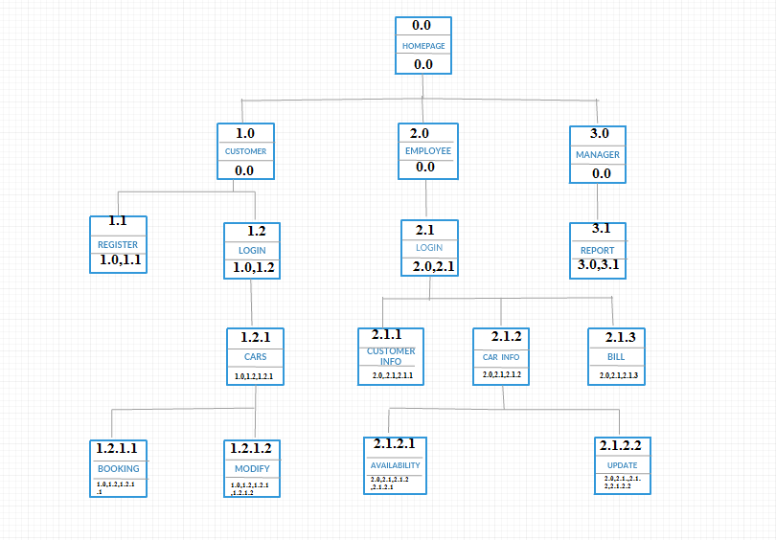

**Figure 3.7 Dialogue Diagram for OCRMS**

Table 3.8 Description Of User Interface Components

|  |  |  |
| --- | --- | --- |
|  | Home Page | This page is visble to all user before login . When customer login,system will go to home page with all the function accessible.Same thing happen when employee login. |
|  | Registeration Page | Registereration page will popup the register hyperlink is clicked.Customer need to fill up the required personal details. |
|  | Login Page | Customer will enter username and password and click login button for access the system. |
|  | About Us Page | About Us will display information about our company. |
|  | Contact Us Page | Button Contact Us will display about company’s contact. |
|  | Cars Page | Inside the car paged there are list of cars with details required for rental. Customer can search and choose the car they wants to book. |
|  | Availability Page | This page list all the cars.Employee can updated car avaibility here. |
|  | Customer List Page | This page display customers details for employee to view. |
|  | Bill Page | This page display the bill for respective car rentaling process. |

[**3.2.2**. **HARDWARE INTERFACES**](#_Toc208811462)

1.Not applicable

**3.2.3** [**SOFTWARE INTERFACES**](#_Toc208811462)

1. Mozilla, Chrome and Internet Explorer for browse the portal of Online Car Rental Management System.
2. NetBeans IDE 8.0 for developing system with use java language.

**3.3 Requirements Traceability**

Table 3.9 Traceability Matrix for A

|  |  |
| --- | --- |
| SFR-OCRMS-RM-01 | Use Case Registration Module |
| SFR-OCRMS-LM-01 | Use Case Login Module |
| SFR-OCRMS-LM-02 | Use Case Login Module |
| SFR-OCRMS-BM-01 | Use Case Booking Module |
| SFR-OCRMS-BM-02 | Use Case Booking Module |
| SFR-OCRMS-BM-03 | Use Case Booking Module |
| SFR-OCRMS-BM-04 | Use Case Booking Module |
| SFR-OCRMS-BM-05 | Use Case Booking Module |
| SFR-OCRMS-BM-06 | Use Case Booking Module |
| SFR-OCRMS-BM-07 | Use Case Booking Module |
| SFR-OCRMS-FM-01 | Use Case Generating Module |
| SFR-OCRMS-IM-01 | Use Case Management Module |
| SFR-OCRMS-CM-01 | Use Case Customerinfo Module |

Table 3.10 Traceability Matrix for B

|  |  |
| --- | --- |
| **Use Case diagram** | **GUI Component** |
| Use Case Registration Module | Registration interface for customer. |
| Use Case Login Module | Login interface for customer and employee. |
| Use Case Management Module | Management interface for employee to manage car details |
| Use Case Booking Module | Booking Module interface for customer to book the car and employee to update car availability. |
| Use Case Generating Module | Generating Module interface for employee create receipt. |
| Use Case Customerinfo Module | Employee view customer details using this module. |

Figure 3.8 Traceability Matrix for B

Manage Customer Info

Generate Bill

SFR-ORCMS-CM-01

SFR-ORCMS-IM-01

SFR-ORCMS-FM-01

SFR-ORCMS-BM-08

SFR-ORCMS-BM-07

SFR-ORCMS-BM-06

SFR-ORCMS-BM-05

SFR-ORCMS-BM-04

SFR-ORCMS-BM-02

SFR-ORCMS-BM-03

SFR-ORCMS-BM-01

SFR-ORCMS-LM-02

SFR-ORCMS-LM-01

SFR-ORCMS-RM-01

Manage Car Info

Manage Booking

Login

Register

1. **ACRONYMS AND ABBREVIATION**

Table 4.1 Terms and Definitions

|  |  |
| --- | --- |
| **TERM** | **DEFINITION** |
| OCRMS | Online Car Rental Management System |
| SRS | Software Requirements Specification |
| SDP | Software Development Plan |
| SQL | Structure Query Language |
| PHP | PHP: Hypertext Preprocessor |
| UCD | Use Case Description |

**APPENDIX A**

**Sequence diagram**



Appendix A1 Sequence Diagram for Register Module



Appendix A2 Sequence Diagram for Login Module



AppendixA3Sequence Diagram for Login Module



AppendixA4 Sequence Diagram for Booking Module



AppendixA5 Sequence Diagram for Booking Module



AppendixA6 Sequence Diagram for Management Module



AppendixA7 Sequence Diagram for Customer Info Module



Appendix A8 Sequence Diagram for Generating Module

**APPENDIX B**

**User interface**

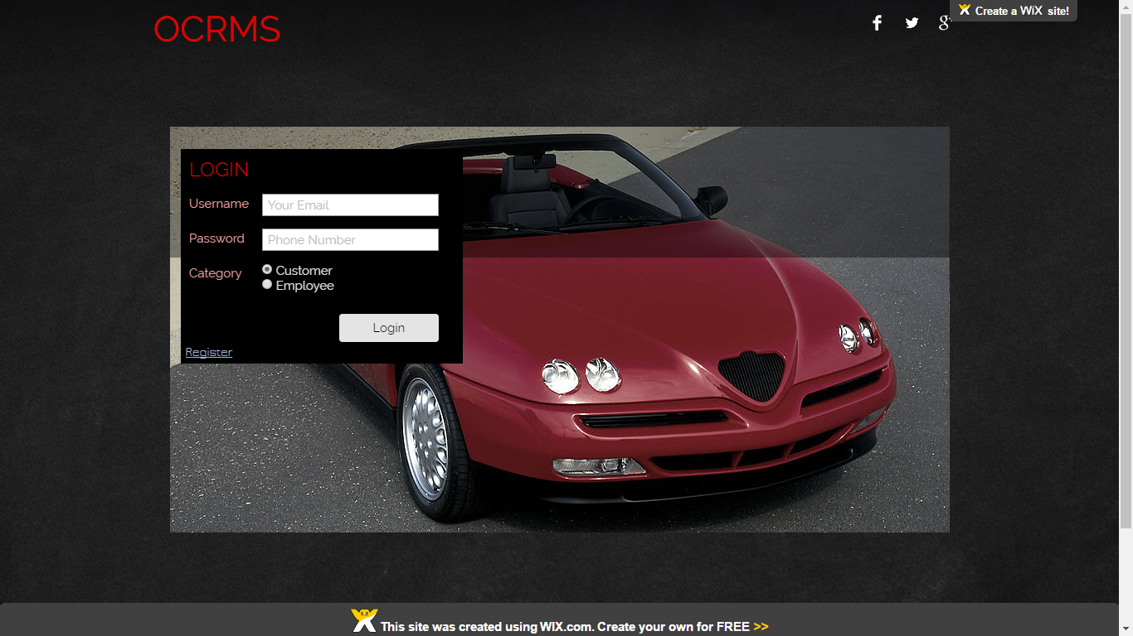

Appendix B1 Home Interface

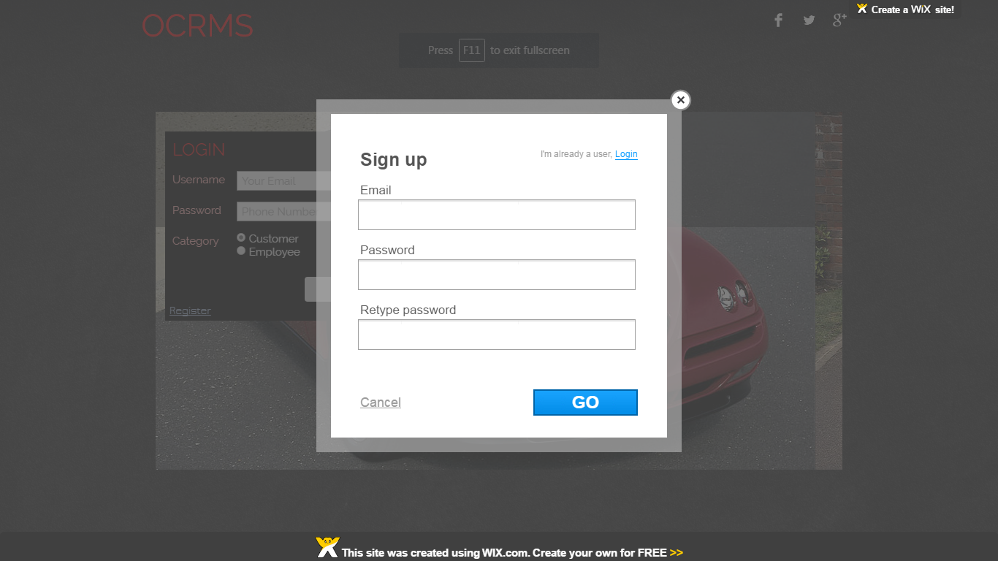

Appendix B2 Registeration Interface

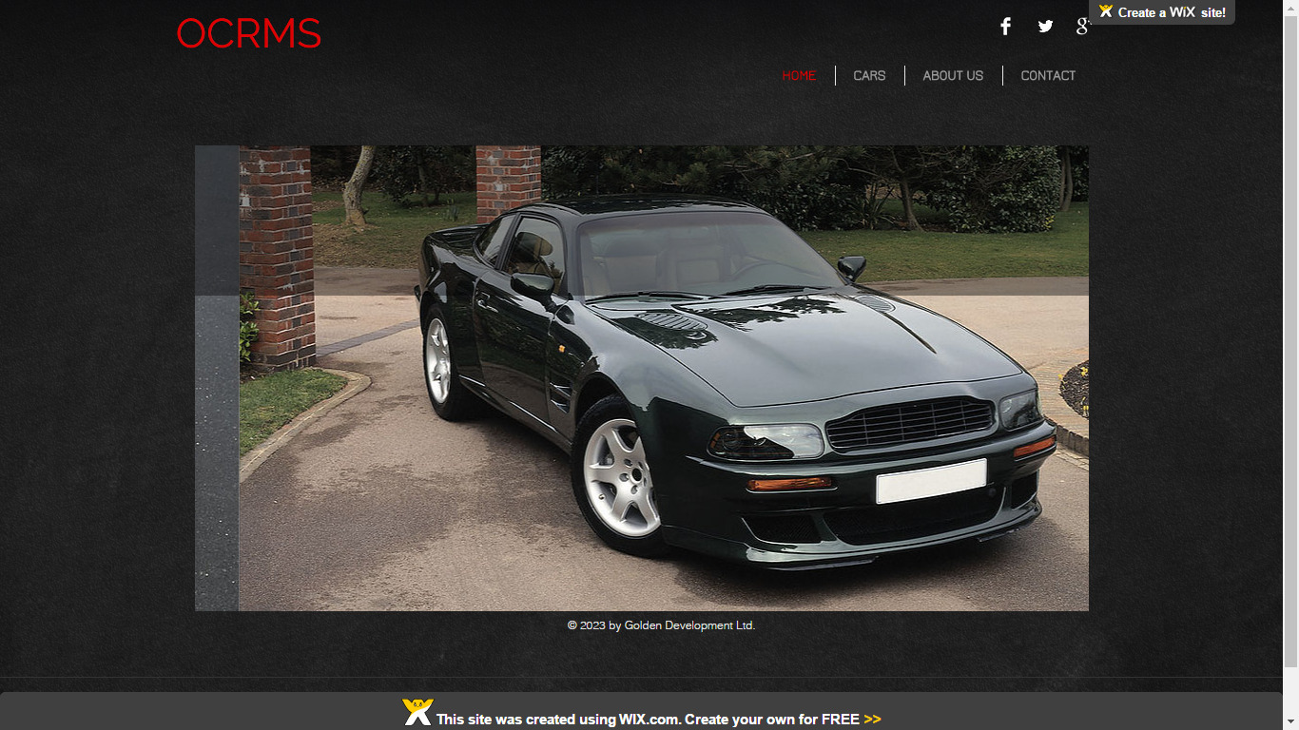

Appendix B3 Home Interface after Login

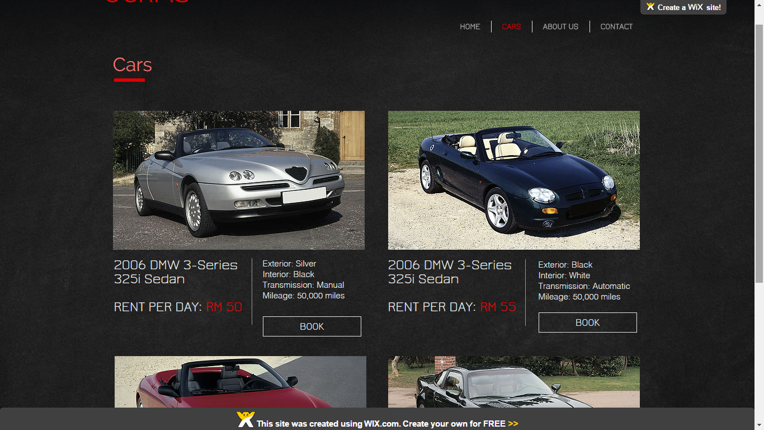

Appendix B4 Car Rental Interface

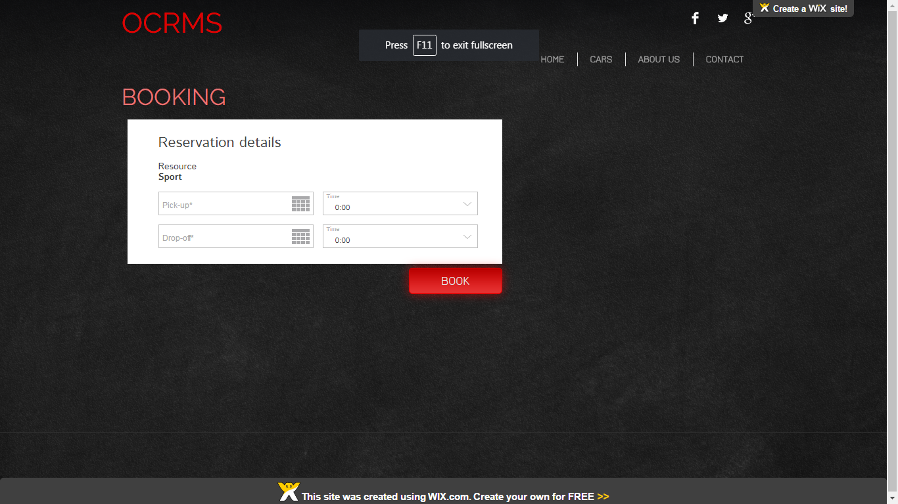

Appendix B5 Booking Interface

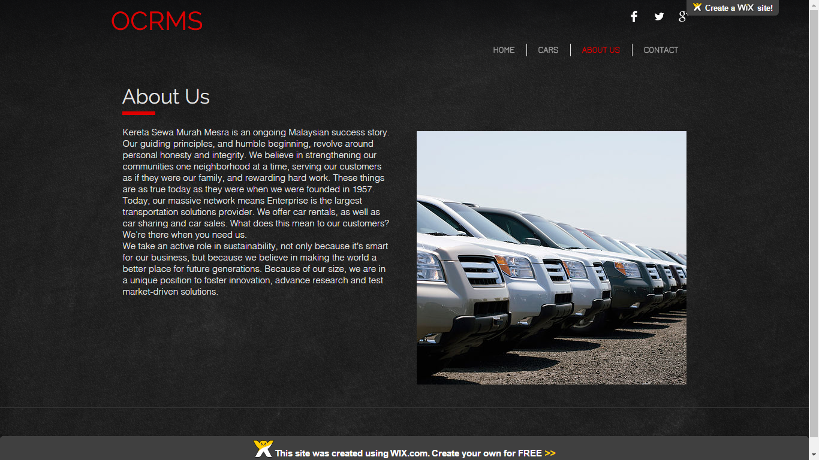

Appendix B6 About Us Interface

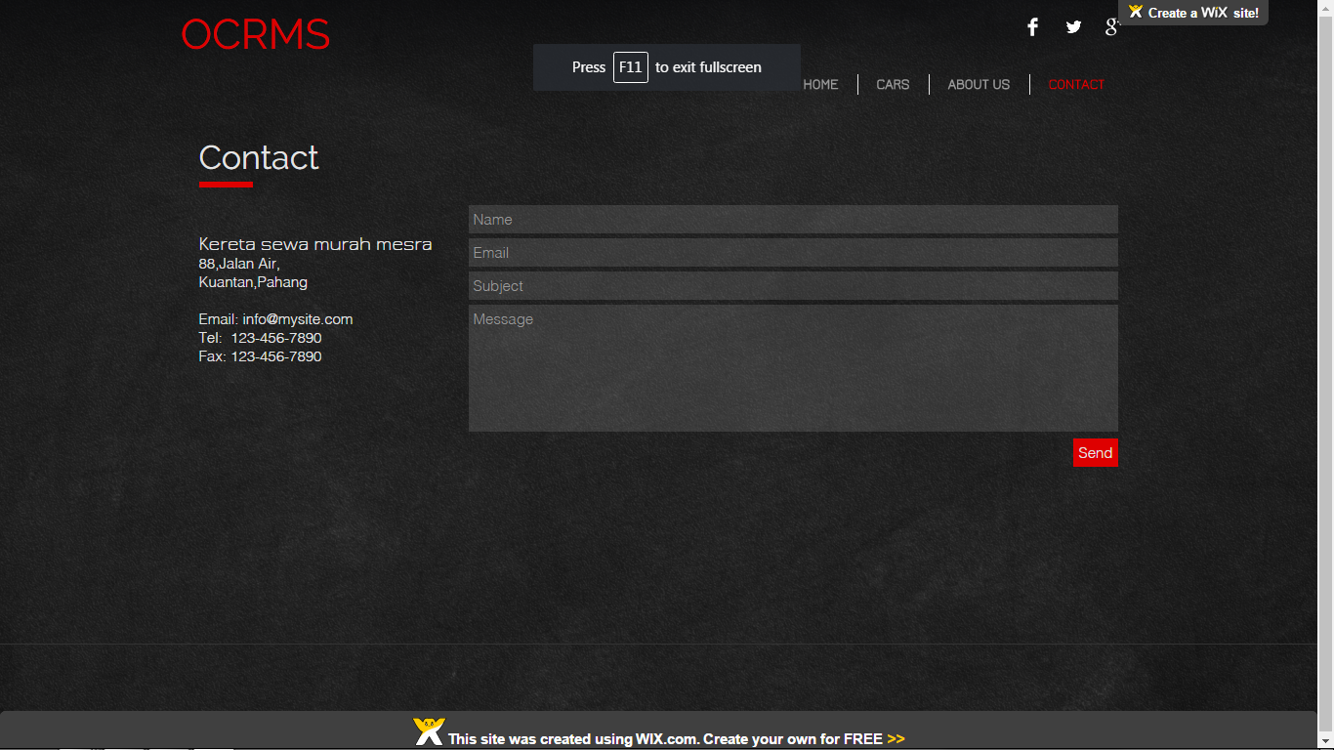

Appendix B7 Contact Interface

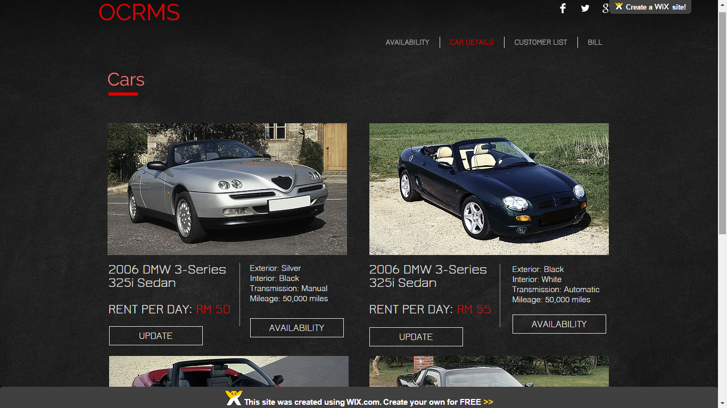

Appendix B8 Car Details Interface

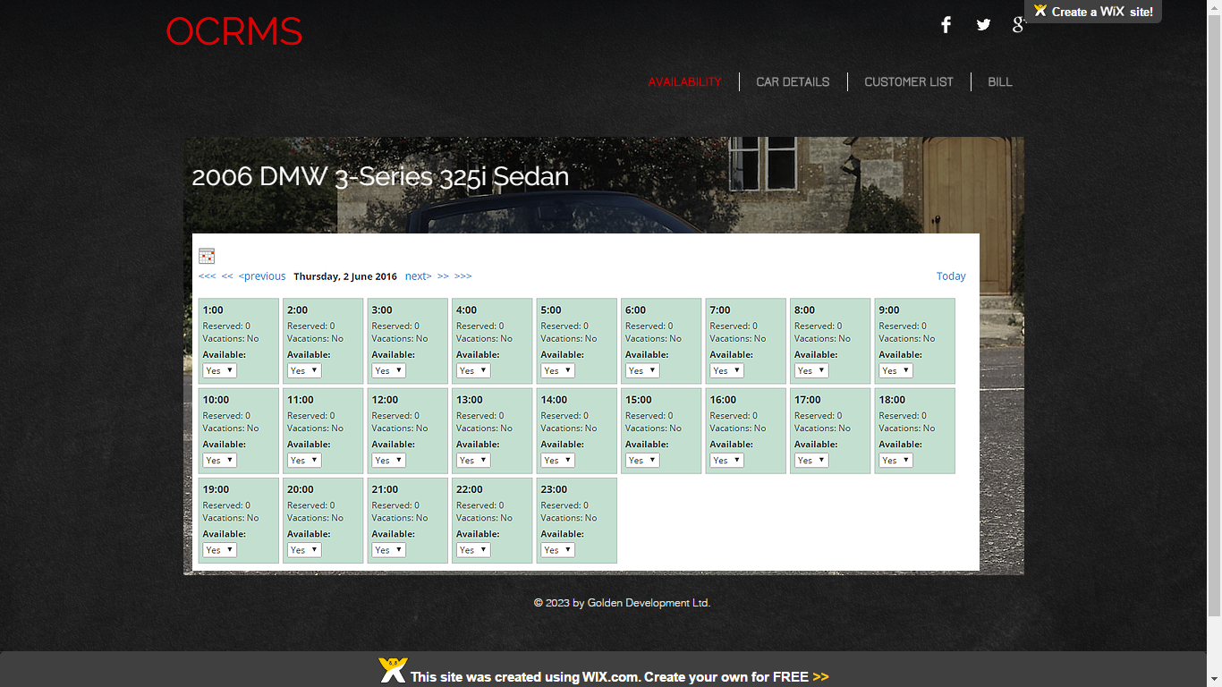

Appendix B9 Car Availability Interface

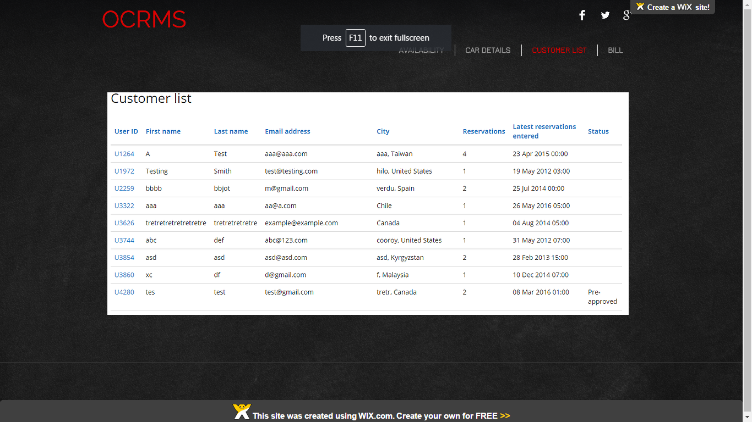

Appendix B10 Customer Details Interface

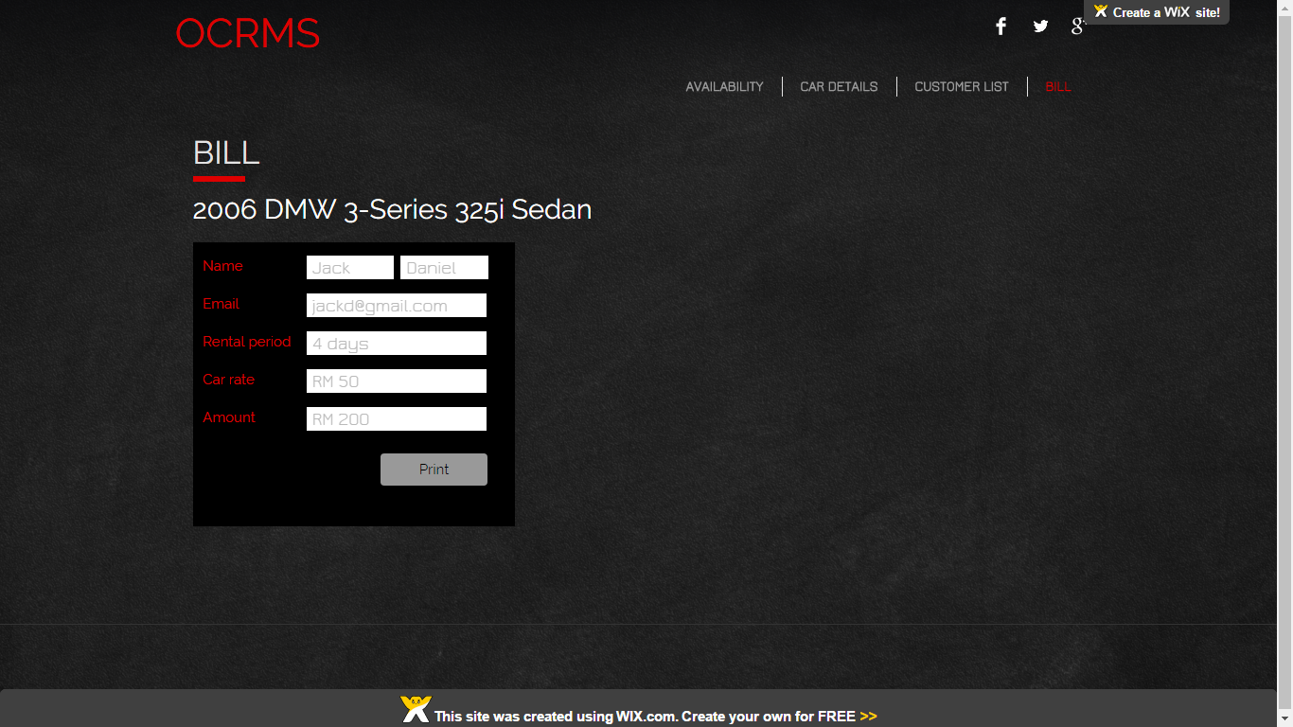

Appendix B11 Bill Interface